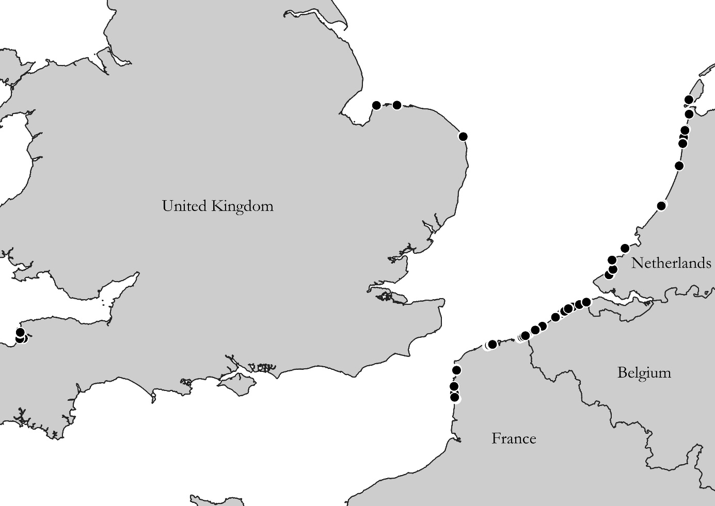
S.5.1 Sampling locations for the theoretical food web
Figure S.5.1: Overview of all biodiversity samples taken along the Channel and the North Sea. 206 samples were taken along the Belgian coast, 184 along the French coast, 188 along the Dutch coast and 60 along the coast of the United Kingdom.

